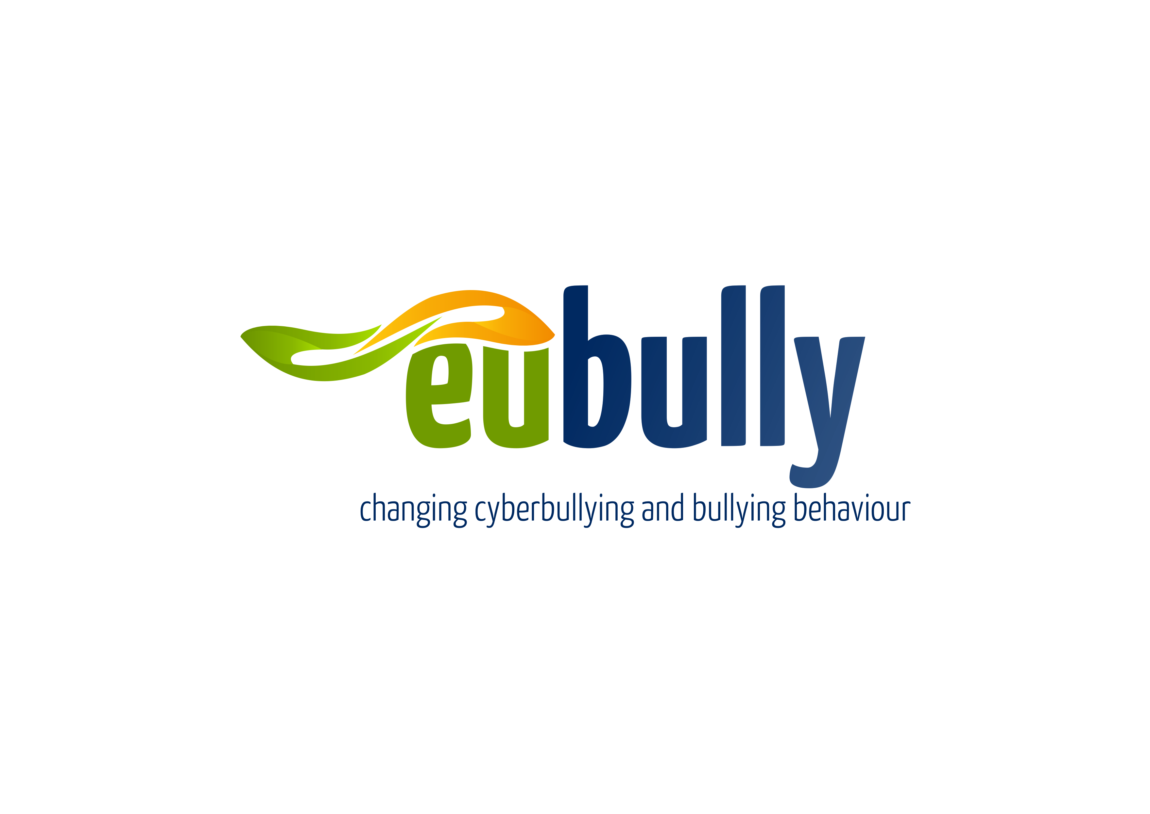

EUBULLY : InSite drama training 26th and 27th November 2015: Registration form .

All information provided will be kept confidential.

About yourself

What is your name?
Please provide your contact details | Address with post code  E mail:

What is the name of the school, organisation or community in which you work or volunteer?
What is your job/volunteer title?
Is your organisation a public, private or third sector organisation?
Please describe your role in your organisation or community
How does your work / volunteering involve you in bullying?

Thank you for completing this questionnaire.

Please return your completed questionnaires to jim@bully4u.ie no later than 20th November,2015.

